Welcome, everyone, to your 2016 Rallye Rally !!!

SATURDAY 4th JUNE 2016 – Fallback date 11th June if 4th washed out – PLEASE CALL UK 07445942132 or 07950772459 or 07970883448 before setting off.
We look forward to seeing you on Saturday 4th of June 2016 at Forwood Farm Airstrip, east of Retford (Gamston) Airport, and west of Cottam Power Station (which lies by the River Trent.) All Rallyes, Kolibers and TBs are very welcome.
The 02/20 grass strip is owned and run by Dave and Stephanie Bell and is 550 x 30m.
It’s west of Treswell village, and runs down the south-east side of Treswell Wood, the large "C" shaped wood you can see to the west of the village on Google Earth or the OS map. (not to be confused with a shorter East/West strip lying 1/2 mile west at the NW corner of the wood). There’s a windsock at the north-east corner of the airfield.
Coordinates are 53 deg.18' 20"N, 0 deg.51' W. GAM VOR 112.8, 068/3.75nm.
We’ll be using the microlight frequency of 129.82 so Headon Airfield is aware of us.

Three maps follow to show the location of Forwood Farm. The airstrip runs SSW from adjacent to Forwood Farm itself, to the south-east end of Treswell Wood, and is now visible on Google Earth. The footpath alongside is quite separate, there is a hedge between the path and the airstrip. .
There’s a large gliding field four miles to the south at Darlton, and a microlight field two miles to the south-west at Headon, so to avoid these we suggest arrivals, departures and circuits to the east towards Cottam Power Station (1 chimney, 2 x 4 towers and pink powerhouse!). Approaching for 20, line up between North Leverton windmill and some polytunnels. and you have a clear run in with the wood on your right, and it’s best to land after the track to the farmhouse on your left. Approaching for 02, angle round by Rampton Hospital, the large complex with green roofs one mile south of the strip (please avoid direct overflight if you can), onto final with the wood on your left; there are low wires two long fields before the strip but these are no problem at all.
As always, please avoid overflying local villages wherever possible.
Food and drink will be available on the field. Avgas is available at Gamston or Netherthorpe airfields to the west, or Wickenby to the east, (or.Sturgate Airfield, 8 miles to the north-east. (Payment there by cash or cheque only)).
There's plenty of parking, and room for tents, also caravans if you can persuade someone to bring one! Otherwise we can organise accommodation in nearby villages/towns if required - please let us know what you need.

Any queries or requests you may have, please don't hesitate to contact me by phone on Home +44(0)1427-880693 (+ answerphone), or Mobiles 07445942132 or 07950772459, or e-mail me on edwards_airways@yahoo.co.uk.
Even if you can’t make the rally weekend, all light aircraft are always welcome to drop in to Forwood Farm on PPR to Dave Bell on 07970883448 – just give us a call and we look forward to seeing you.

With best wishes,
Ruth Edwards and Dave & Stephanie Bell , MS880B G-BYPN joint owners.
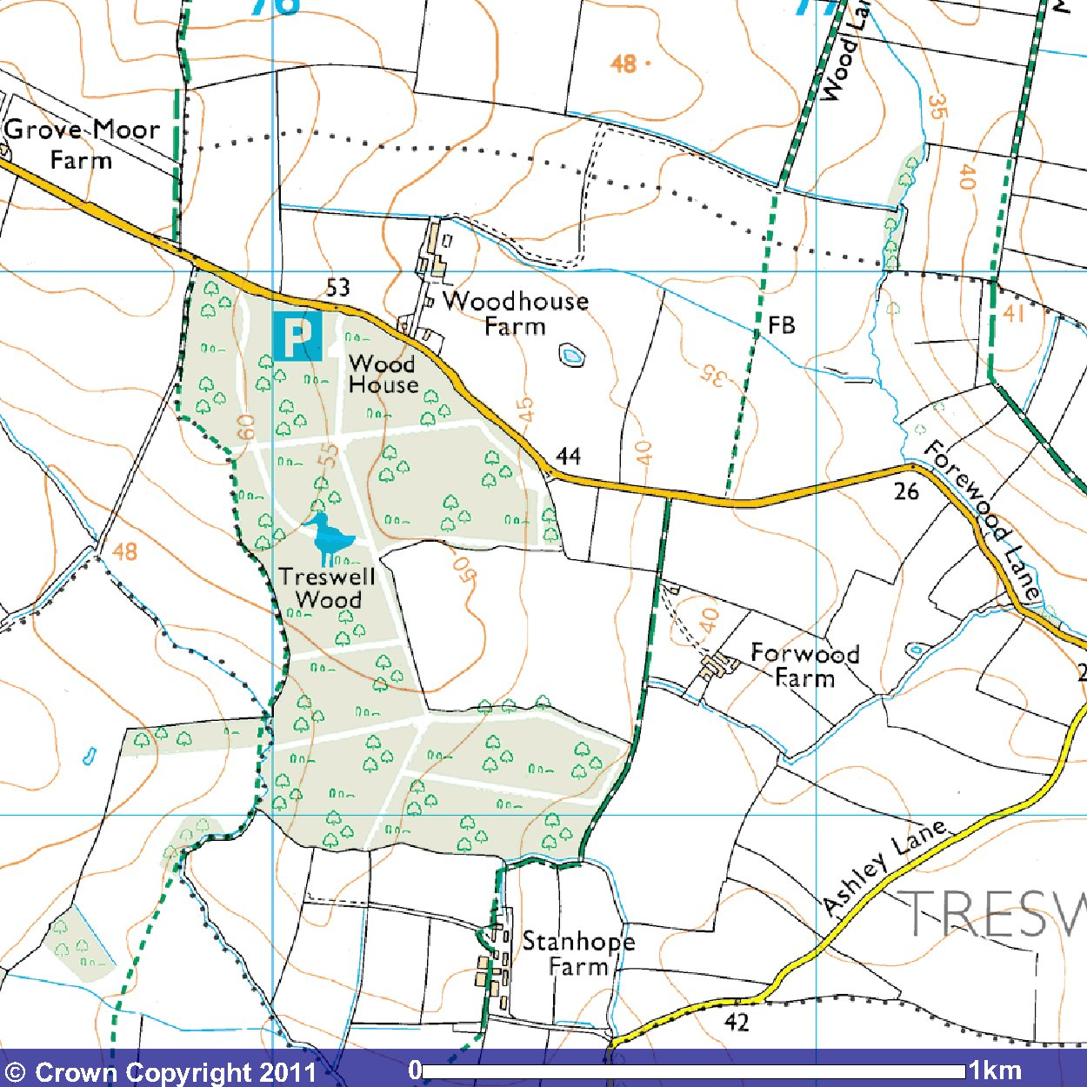

Forwood Farm is in the lower right centre of this map, showing the “C” shaped wood (with bird symbol) to the west of the farm. The airstrip runs down the south-east side of this wood, and is visible on Google Earth.

Enter “Treswell” in the Google Earth search box; the village will come up in the centre of the screen. Drag the village eastwards until you see the “C” shaped wood to the west of the village. The airstrip is clearly visible at the south-east corner of the wood.

Forwood Farm is at the north-east end of the airstrip, and there is an aircraft parked on the grass. (It was evidently a good flying day; our Rallye is missing !!).

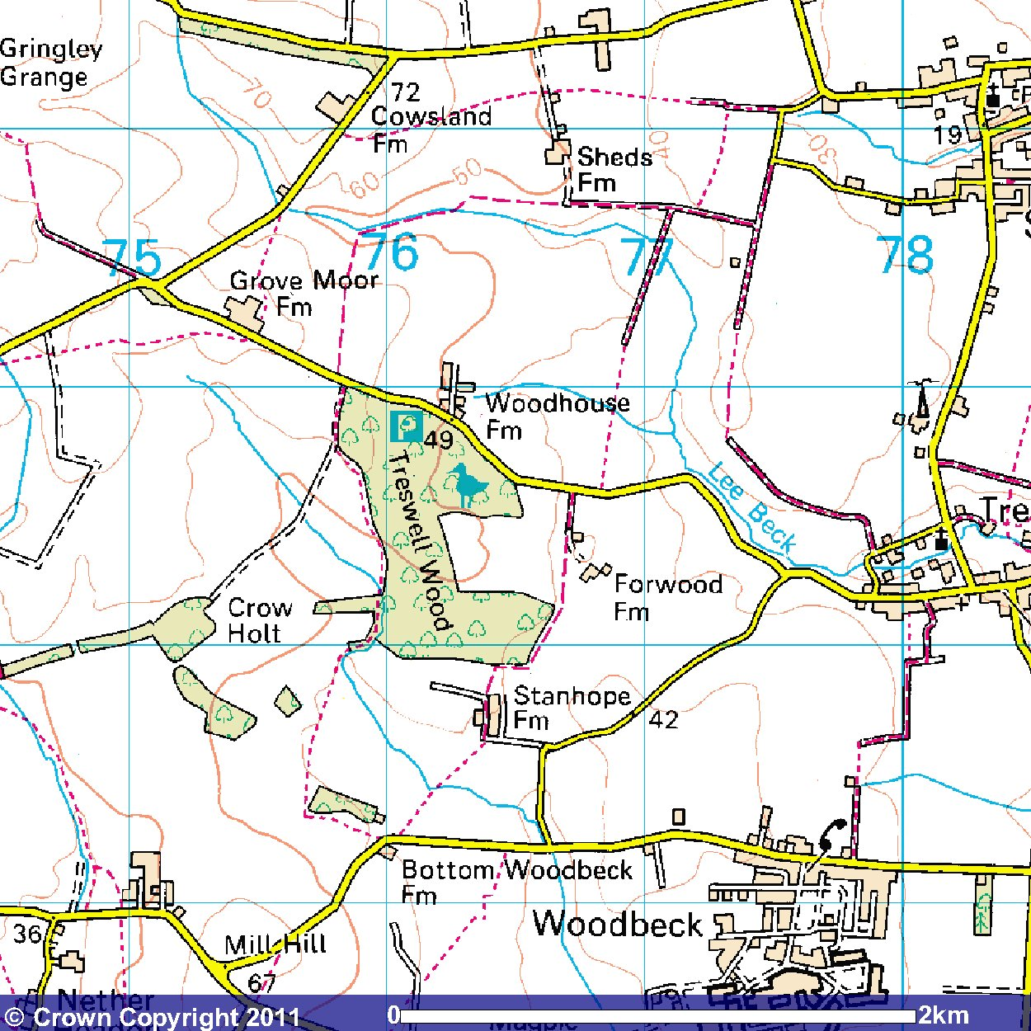

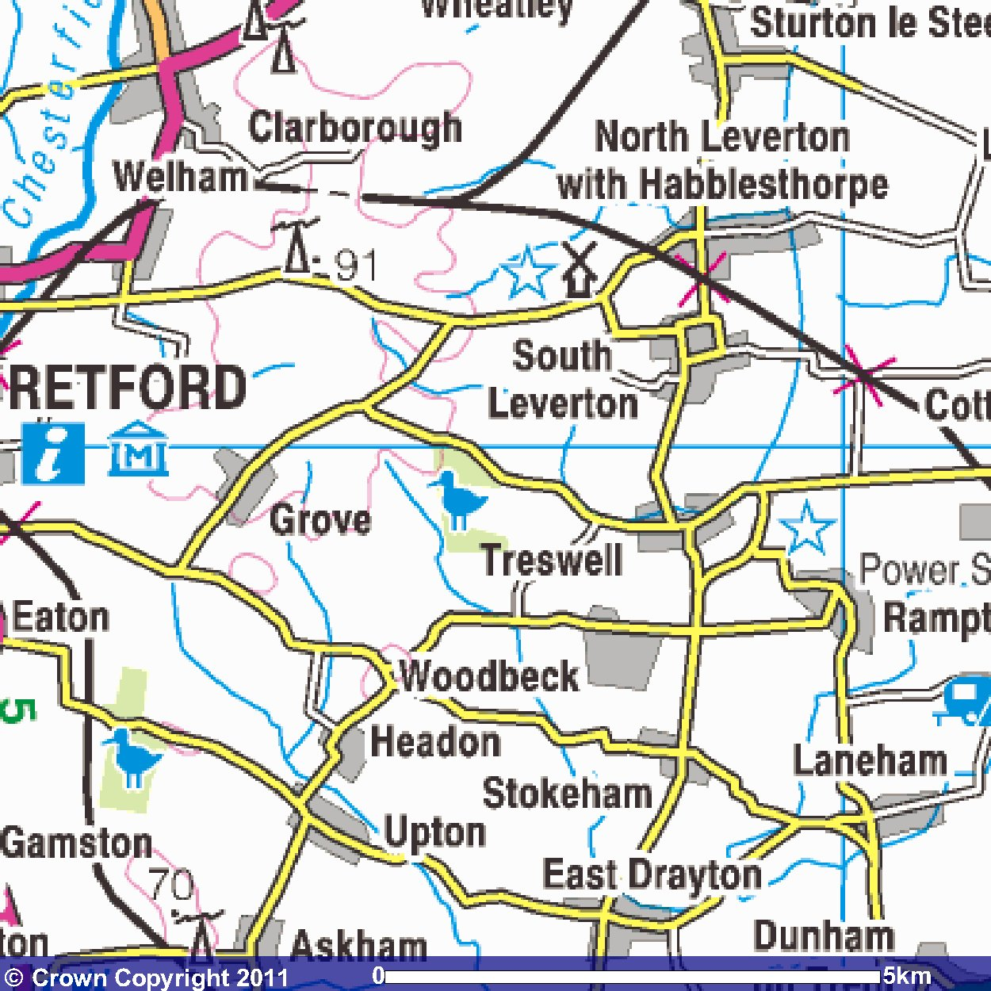

Treswell village is in the centre of this map, with the “C” shaped wood with the bird symbol to the west of the village.

